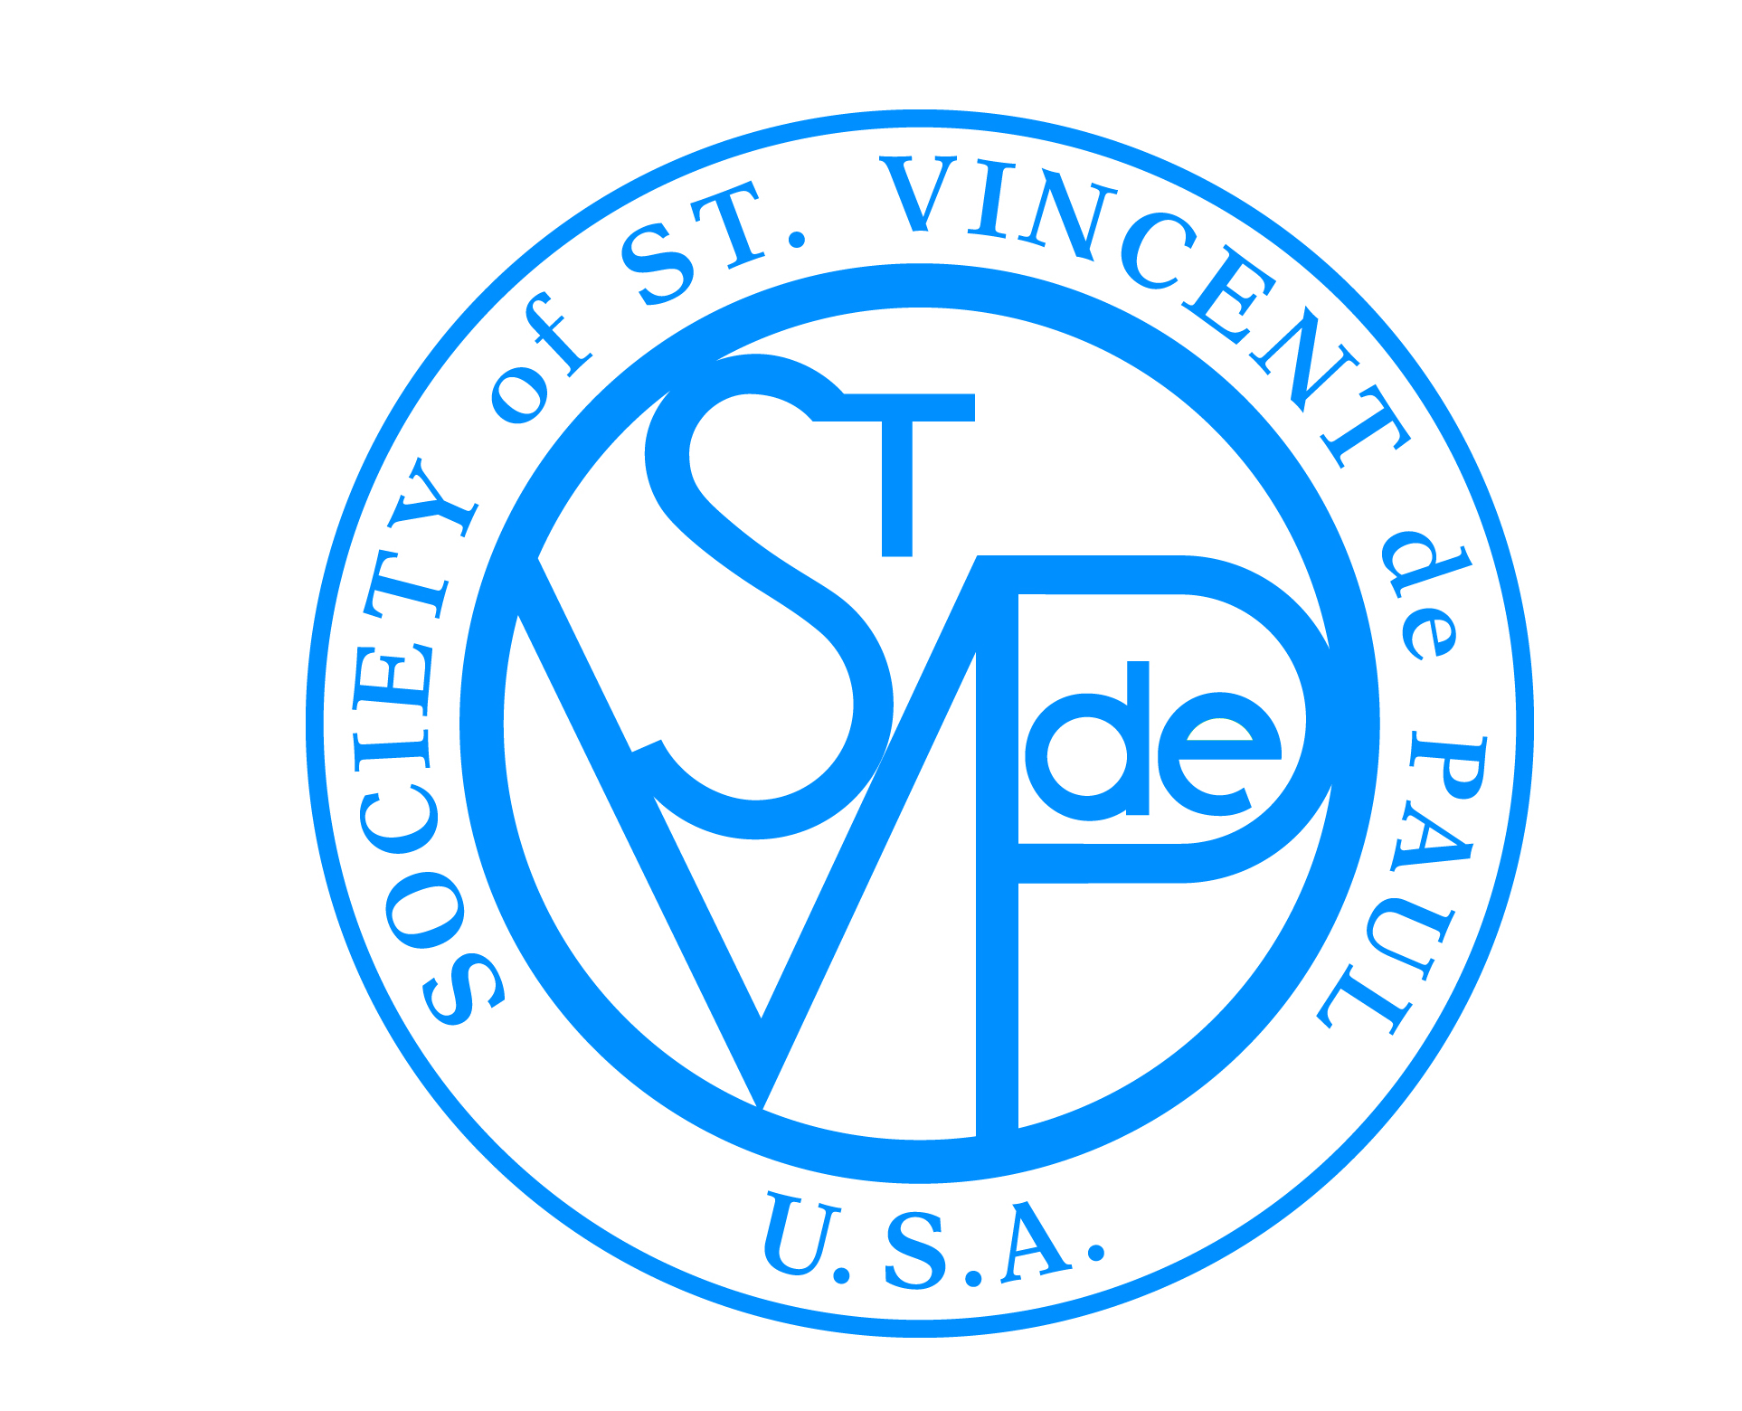SUCCESSION PLANNING:
LIST OF RESOURCES FOR INCOMING
(ARCH)DIOCESAN & DISTRICT COUNCIL PRESIDENTS

Required Reading:
- The Rule
- Bylaws
- Standards of Excellence for Councils
- Council President manual
- Governance: Council/Board manual
- Annual budget
- Year-end financials for the previous 3-4 years
- Legal documents (e.g., 501(c)(3), 990 tax forms, etc.)

Recommended Reading:
- Job description
- National mentoring program materials
- Council President and Executive Directors: Process for a Successful Partnership document
- Minutes from regional, midyear and national meetings (at least one year)
- Minutes from (arch)diocesan or council board meetings (at least one year)
- A Vincentian Guide to Diversity/Multicultural Issues
- Governance-in-a-Box

Recommended Activities for President-Elect During Transition Period:
- Participate in national mentoring program.
- Observe local board meetings.
- Meet with current president to discuss (arch)diocesan or district council operations on a monthly basis.
- Meet with current president to discuss activities at regional, midyear and national meetings.
- Attend regional, midyear and/or national meetings.
- Attend Invitation for Renewal retreat.
- Meet with current president and regional vice president (in person if possible).
- Meet with national council member.
- Include past president as ex-officio member of your future board and council.
- Complete Values-Centered Leadership Course (online) at DePaul University.

Assumes a six-month overlap with president and president-elect.

