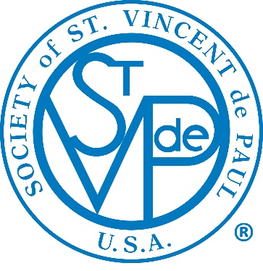

Society of St. Vincent de Paul

Mentoring Program Application Packet

Goal of National Leadership Mentoring Program
The goal of the National Leadership Mentoring Program is to match and connect experienced council leaders (mentors) with prospective and new council leaders (mentees) based on similarities such as council size, strengths of the mentor, needs of the mentee and other pertinent considerations so that new leaders can be successful in fulfilling the needs of their community and promote the development of excellence in leadership resulting in enhanced vision and mission execution efforts for the Society of St. Vincent de Paul.

Time Commitment
The program commitment is for a minimum of one year and can be extended by the mutual agreement of the mentor and mentee.

Qualifications & Responsibilities of the Mentor

- Must have a minimum of three years of executive or senior leadership and currently serve as (or recently retired as) an Executive Director or President of an SVDP Council;
- Have completed Ozanam Orientation and have participated in Invitation for Renewal;
- Have participated in Invitation for Renewal (recommended but not required);
- Have submitted the attached application, professional resume, and organizational resume (a bio can be presented if a formal resume is unavailable);
- Be available for a minimum of one monthly phone call or face to face meeting (whichever is most practical);
- Communicate via email on a regular basis based on the needs of the mentee and the schedules of both participants;
- Participate in a quarterly status call with a coordinator of the program;
- Work to identify and achieve the goals of the mentee;
- Participate in an initial introductory phone call with a program coordinator and mentee;
- Contact a program coordinator as needed to discuss any concerns or to gain access to additional resources that will be helpful to the mentor/mentee relationship.

Qualifications & Responsibilities of the Mentee

- Currently serve as Executive Director or President of an SVDP Council with 36 months or less experience;
- Have participated or plan to participate within 12 months in Invitation for Renewal and Ozanam Orientation;
- Have submitted the attached application, professional resume, and organizational resume (a bio can be presented if a formal resume is unavailable);
- Be available for a minimum of one monthly phone call or face to face meeting (whichever is most practical);
- Communicate via email on a regular basis based on your needs and the schedules of both participants;
- Participate in a quarterly status call with a coordinator of the program;
- Work to identify and achieve your goals;
- Participate in an initial introductory phone call with a program coordinator and mentor;
- Contact a program coordinator as needed to discuss any concerns or to gain access to additional resources that will be helpful to the mentor/mentee relationship.

Questions can be addressed to:
Pam Hudson Johnson
National Director of Governance and Membership Services
phudson@svdpusa.org
(314) 576-3993 ext 214

Society of St. Vincent de Paul

National Mentor Program Participant Application

Date: ____________________________ Applying to be (check one) _____ Mentor _____ Mentee

SVdP (Arch)Diocesan or District Council Name:______________________________________________

Conference Member of: ________________________________________________________________
(Name of Your Parish Conference/City & State)

Applicant Name:_______________________________________________________________________

Address:______________________________________________________________________________
Street City State Zip Code

Preferred Phone:__________________________ Email:__________________________________

SVDP Education, Training and Experience:

Position in Society: ____ CEO/Executive Director _____ Council President

Dates Active: __________________________________________ Retired: _____Yes _____No

Past Positions Held in Society:

- _______________________________________________ Dates:____________________

- _______________________________________________ Dates:____________________

- _______________________________________________ Dates:____________________

Place a check mark next to all orientation/training/programs you have completed/attended:

_____ Ozanam Orientation _____ Invitation for Renewal

_____ National Vehicle Donation Program _____ Friends of the Poor Walk

_____ Governance Training _____ Hope in Action (Systemic Change)

_____ National Assembly (Years_________) _____ Midyear Meeting (Years____________)

_____ Serving In Hope Other ______________________________

MENTEES PLEASE ANSWER THE FOLLOWING: in applying for a mentor please describe any needs, issues or concerns you want addressed in a mentor-mentee relationship. _______________________________________________________

Please email completed form and any questions to Pam Hudson Johnson, phudson@svdpusa.org

