VINCENTIAN REFLECTIONS
Second Quarter 2026



Liturgical Year: A

(April – May – June)

Available on SSVPUSA.org



HOW TO LEAD THE VINCENTIAN REFLECTIONS IN A CONFERENCE

INTRODUCTION:
Leader describes to the group the process which is going to take place:
- Provide a copy for each member of your Conference for their personal reflection
- Stress that sharing is not compulsory and mention the need for confidentiality
- Ask, or assign, different members to read the different sections:
-Gospel reading
-Reflection
-Vincentian Meditation

OPENING PRAYER/QUIETING DOWN PERIOD
Leader invites group to:
- Become relaxed and aware of God’s presence with us
- “Let Go” of distractions and quietly pray to the Holy Spirit

READING OF THE VINCENTIAN WEEKLY REFLECTION
- Each section is read aloud, slowly and prayerfully, by the different members
- Hearing different voices will allow different emphasis on words/phrases

QUIET PERIOD
Leader invites everyone:
- To quietly reflect on the readings and notice if anything strikes them
- Introduces the Discussion Question suggested in the Reflection
- Allows 2-3 minutes of quiet – don’t hurry this. God speaks to us in the silence.

SHARING
Leader invites members who wish to share on the Discussion Question, or on how
the one of the readings struck them. Possibly not everyone will share, but time should be allowed for each person who wishes to share his/her thoughts. It is important that you resist the urge either to prod members to share, or to try to “fill the silence” with your own thoughts.

CLOSING PRAYER
Leader closes the Prayer Reflection by beginning the Closing Prayer, and all answer the response (in bold).

(This entire process should take about 10-15 minutes)
INTRODUCTION
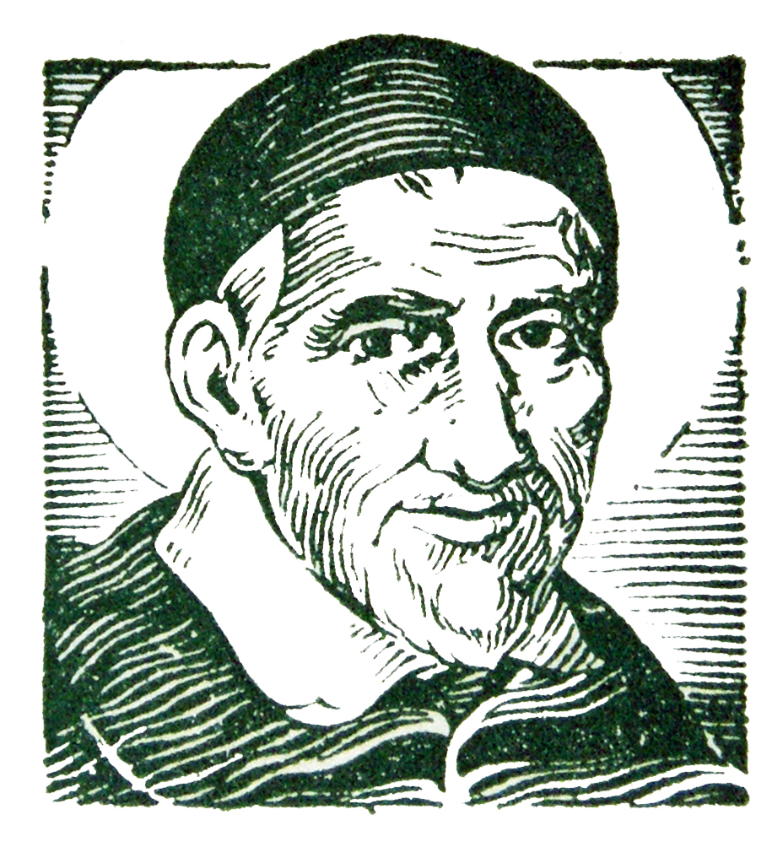
St. Vincent de Paul never wrote a book about his spiritual teachings. But we find the living voice of the saint in his letters and conferences in which he trained his followers for the mission of service to the poor.

The two fundamental sources of his teaching are the GOSPEL and LIFE. He wanted his followers to put the whole of the Gospel into the whole of their lives, and he never wearied of deepening both with all the faith that God had put into his heart. That is why all that Vincent says to us has the simplicity of our everyday life and the penetrating strength of the Word of God.

The Vincentian Weekly Reflections are therefore offered to all who strive to serve the poor in the spirit of St. Vincent de Paul. The prayer and reflections are based on the Sunday Gospel of the Liturgical Calendar, together with the feast days of some of the saints of our Vincentian Family. Each reflection offers a time for prayer, silence and discussion so that our everyday life, like Vincent, can become penetrated with the strength of the Word of God.

You may want to run copies for each member of your Conference so that they may take them home for personal reflection during the week.



LITURGICAL YEAR A
Second Quarter - 2026

APRIL

April 5 Easter Sunday
April 12 Second Sunday of Easter-Divine Mercy
April 19 Third Sunday of Easter
April 26 Fourth Sunday of Easter
April 28 Saint Gianna Beretta Molla

MAY

May 3 Fifth Sunday of Easter
May 9 Feast of St. Louise de Marillac
May 10 Sixth Sunday of Easter
May 17 Ascension
May 24 Pentecost
May 31 Most Holy Trinity

JUNE

June 7 The Most Holy Body and Blood of Christ
June 12 Feast of the Sacred Heart
June 14 Eleventh Sunday of Ordinary Time
June 21 Twelfth Sunday of Ordinary Time

June 28 Thirteenth Sunday of Ordinary Time

EASTER SUNDAY
April 5, 2026
Gospel: (John 20:1-9)
On the first day of the week, Mary of Magdala came to the tomb early in the morning, while it was still dark, and saw the stone removed from the tomb. So she ran and went to Simon Peter and to the other disciple whom Jesus loved, and told them, “They have taken the Lord from the tomb and we don’t know where they put him.” So Peter and the other disciple went out and came to the tomb. They both ran, but the other disciple ran faster than Peter ; he bent down and saw the burial cloths there…and he saw and believed. For they did not yet understand the Scripture that he had to rise from the dead.
Reflection:
Even on this most glorious of days, the gospel incorporates contradictions: Mary of Magdala arrives at an empty tomb, and sees that Jesus is gone and “we don’t know where they have put him” while the disciple whom Jesus loved enters the tomb and “saw and believed”; they “did not yet understand the Scripture.” Our own Alleluias and Easter joy are perhaps filled with some of the same contradictions. It seems as though we, too, peer into the empty tombs of the ups and downs of our everyday lives and are challenged to see and believe. But we are the disciples whom Jesus loves; and we surrender ourselves to the Easter mystery when we return love. All we need to do is hand ourselves over into God’s hands. Filled with God’s love, we are then able to love in return. Alleluia! The tomb is empty; by our love we see and believe, and we are filled with new life. Alleluia! (Living Liturgy, p.112)
Vincentian Meditation:
“We must develop the practice of making frequent acts of the desire to know God and ourselves. This will lead us to make the repeated acts of love which we owe Him and to avoid anything that is displeasing to Him. We must often abandon ourselves to Him, show Him our hearts filled with trust and gratitude; and try from time to time to whisper prayers to Him.” -St. Louise de Marillac- (Gibson and Kneaves, Praying with Louise, p.95)
Discussion: (Share your thoughts after a moment of silence)
Is our prayer life filled with repeated acts of love and abandonment to God?
How do we “see and believe” as we live our life today?

Closing Prayer:
Risen Lord, through your triumph of the cross,
May our sufferings lead us to deeper union with you.
Risen Lord, you brought faith and hope to your disciples,
May we abandon ourselves to you, in trust and gratitude.
Risen Lord, your resurrection formed a community of believers,
Give us true love for one another.
Risen Lord, you give God’s love poured out in our hearts,
Make us beloved disciples who “see and believe.”
Amen

SECOND SUNDAY OF EASTER

April 12, 2026
Gospel: (John 20:19-31)
On the evening of that first day of the week, when the doors were locked, where the disciples were, for fear of the Jews, Jesus came and stood in their midst and said to them, “Peace be with you.” When he had said this, he showed them his hands and his side. The disciples rejoiced when they saw the Lord. Jesus said to them again, “Peace be with you. As the Father has sent me, so I send you.” And when he said this, he breathed on them and said, “Receive the Holy Spirit.” A week later…Jesus said to Thomas, “Put your finger here and see my hands and bring your hand and put it into my side, and do not be unbelieving, but believe.” Thomas answered and said to him, “My Lord and my God!” Jesus said to him, “Have you come to believe because you have seen me? Blessed are those who have not seen and have believed.”
Reflection:
The disciples were gathered behind locked doors because of fear, then the Risen Jesus stands in their midst and they are then filled with joy as Jesus speaks words of peace and forgiveness. Peace and forgiveness open up the spaciousness of salvation, shattering the confines of locked doors and doubt. But Thomas does not believe the witness of the other disciples; he wants tangible evidence. When Jesus offers his hands and side, Thomas rather than touching only utters a profound profession of faith. (Living Liturgy, p.118)
Vincentian Meditation:
“… the poor we see with the eyes of flesh; they are there and we can put finger and hand in their wounds and the scars of the crown of thorns are visible on their foreheads; and at this point incredulity no longer has place and we should fall at their feet and say with the Apostle, Tu est Dominus et Deus meus (You are my Lord and my God!). You are our masters, and we will be your servants. You are for us the sacred images of that God whom we do not see, and not knowing how to love Him otherwise shall we not love Him in your person? (Ramson, Praying with Frederic, p.98)
Discussion: (Share your thoughts on the readings after a moment of silence)

How do we have the eyes of faith , like Frederic, to see the Risen Jesus whose scars and nail prints the poor and suffering bear on their bodies?
Closing Prayer:
O Lord, give us the grace to live the Corporal works of Mercy:
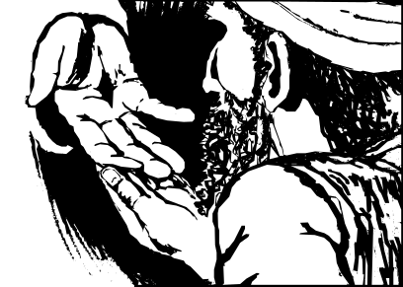
To feed the hungry, give drink to the thirsty, clothe the naked, visit those in prison, shelter the homeless, visit the sick and bury the dead.
And may our lives reflect the Spiritual works of Mercy:
To admonish the sinner, instruct the ignorant, counsel the doubtful, comfort the sorrowful, bear wrongs patiently, forgive all injuries, and to pray for the living and the dead.
Amen
THIRD SUNDAY OF EASTER
April 19, 2026
Gospel: (Luke 24:13-35)
That very day, the first day of the week, two of Jesus’ disciples were going to a village seven miles from Jerusalem called Emmaus, and they were conversing about all the things that had happened. And while they were conversing and debating, Jesus himself drew near and walked with them. …and then Jesus said to them, “Oh, how foolish you are! How slow of heart to believe all that the Prophets spoke! Was it not necessary that the Christ should suffer these things and enter into his glory?” Then beginning with the Moses and all the prophets, he interpreted to them what referred to him in all the Scriptures. …They urged him, “Stay with us, for it is nearly evening and the day is almost over.” …While he was with them at table, he took bread, said the blessing, broke it, and gave it to them. With that their eyes were opened and they recognized him, but he vanished from their sight. Then they said to each other, “Were not our hearts burning within us while he spoke to us on the way and opened Scriptures to us?
Reflection:
The disciples had given up hope, they were confused and downcast. But they still had a spark within them and their hearts burned as they once again heard the Scriptures. But they could not see, could not understand. It was only their hospitality, “Stay with us”, in the spaciousness of their reaching out to the Stranger and offering what they could give that their eyes were opened. Our daily reaching out to our neighbor is our daily walk with the risen Christ; we recognize him in others. (Living Liturgy, p.126)
Vincentian Meditation:
“Help honors when to the bread that nourishes it adds the visit that consoles, theadvice that enlightens, the friendly shake of the hand that lifts up the sinking courage; when it treats the poor man with respect, not only as an equal but as a superior, since he is suffering what perhaps we are incapable of suffering; since he is the messenger of God to us, sent to prove our justice and our charity, and to save us by our works.”-Frederic Ozanam- (Ramson, Praying with Frederic, p. 93)
Discussion: (Share your thoughts on the readings after a moment of silence)
When have you found “your hearts burning within you” as you served the poor with the hospitality and “honor” in the spirit of Frederic?
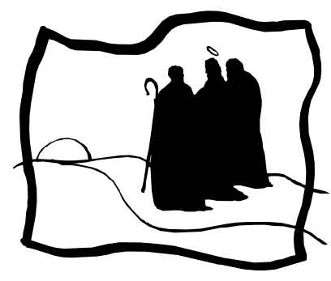
Closing Prayer:
Lord, through your resurrection hope was given to the world,
-strengthen us to be hope for others.
For those who live in fear and loneliness,
-enable us to be peace for others.
For the sick and the dying,
-ignite our hearts to be love for others.
Amen
FOURTH SUNDAY OF EASTER
April 26, 2026
Gospel: (John 10: 1-10)
Jesus said: “Amen, amen, I say to you, whoever does not enter a sheepfold through the gate but climbs over elsewhere is a thief and a robber. But whoever enters through the gate is the shepherd of the sheep. The gatekeeper opens it for him, and the sheep hear his voice, as the shepherd calls his own sheep by name and leads them out. When he has driven out all his own, he walks ahead of them, and the sheep follow him, because they recognize his voice.”…”Amen, amen I say to you, I am the gate for the sheep… whoever enters through me will be saved, and will come and go out and find pasture. I came so that they may have life and have it more abundantly.”
Reflection:
Jesus is the gate, the only entrance to the fold. The image of the gate directs our attention to Jesus the Risen One who always recognizes us and cares for us, to Jesus our Shepherd. This is where resurrection faith leads us so “that we might have life and have it more abundantly.” Christ is truly here for us, calls us by name and leads us to life. (Living Liturgy, p.130)
Vincentian Meditation:
“Surely, the great secret of the spiritual life is to abandon all we love to him by abandoning ourselves to all God wishes in perfect confidence that all will be for the best…He will take the place of father and mother for you. He will be your consolation, your virtue, and in the end the recompense of your love.” -St. Vincent de Paul (McKenna, Praying with Vincent, p. 30)
Discussion: (Share your thoughts on the readings after a moment of silence)
When have we “abandoned ourselves to God in perfect confidence”, and found that Jesus is truly our Shepherd?
Closing Prayer:
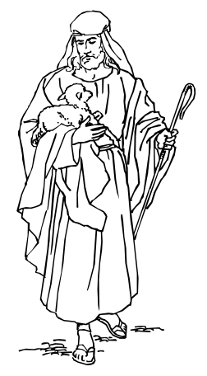
Jesus, our Good Shepherd, you laid down your life so that we might live:
-give us the grace to know that you call us by name.
Jesus, you search out those who are lost,
-give us the grace to know that you bind our wounds.
Jesus, you carry those who cannot walk alone,
-give us the grace to know that you are always with us.
Jesus, you lead those in your flock who hear your voice,
-give us the grace to abandon ourselves to you.
Amen

Feast of Saint Gianna Beretta Molla

April 28
Gospel: (John 20: 19-31)
On the evening of that first day of the week, when the doors were locked, where the disciples were, for fear of the Jews, Jesus came and stood in their midst and said to them, “Peace be with you.” When he had said this, he showed them his hands and his side. The disciples rejoiced when they saw the Lord. Jesus said to them again, “Peace be with you. As the Father has sent me, so I send you.”
Reflection:
Saint Gianna Beretta Molla was born in Italy on October 4, 1922, the tenth of thirteen children. In March 1950 she obtained her degree in medicine and surgery from the University of Pavia, the same school where Blessed Frederic Ozanam’s father had obtained his degree in medicine. It was during medical school that Gianna became an active member of the Society of St. Vincent de Paul. Gianna made a pilgrimage to Lourdes seeking discernment in her vocation. Upon her return, she fell in love with Pietro Molla, and taking this as an answer to her prayers they were married on September 24, 1955. Gianna opened a clinic along with her brother Ferdinando, also a physician. The clinic was located in a small town of two thousand people, and she was especially generous to the poor sick, providing medicine and money for those in need.
Vincentian Meditation:
Gianna and Pietro had three children. Each pregnancy was a risk because of her fragile health. After a number of miscarriages, Gianna became pregnant with her fourth child. Toward the end of the second month she began to experience pain, and a fibrous tumor in the ovary was diagnosed. As a doctor, she knew the risk she was running. She kept her suffering to herself. On the way to the hospital on April 20, 1962, Gianna told her husband Pietro: “If they should ask which of the two lives they should save, do not hesitate…first, the life of the child.” On April 21 she delivered a baby girl, but septic peritonitis set in, and she died on April 29, 1962. Gianna was canonized by Pope John Paul II on May 16, 2004, in the presence of her husband and four children. Saint Gianna has been called a “mother – martyr for the love of God and in obedience to his commandment…” Gianna was a true Vincentian! (Manual P. 87-88)

Discussion: (Share your thoughts after a moment of silence)
How can the Society celebrate and imitate it’s own Saint Gianna?
Closing Prayer:
(Words of Gianna’s son, Pierluigi, at her beatification)
“My mother knew how to live her earthly, daily existence with simplicity, balance and constant service, all in a beautiful harmony, first as a young student and profession person, as a woman, then as wife and mother. Her generous commitment to and involvement in Catholic Action and to the Society of St. Vincent de Paul, along with her joie de vivre, was crowned with her love of piano, painting, tennis, mountain climbing, skiing, the symphony, theatre and traveling.”
Saint Gianna, intercede for us!
Amen

FIFTH SUNDAY OF EASTER
May 3, 2026
Gospel: (John 14:1-12)
Jesus said to his disciples: “Do not let your hearts be troubled. You have faith in God; have faith in me. In my Father’s house there are many dwelling places. If there were not, would I have told you that I am going to prepare a place for you? And if I go and prepare a place for you, I will come back again and take you to myself, so that where I am you also may be. Where I am going you know the way…I am the way, the truth and the life. No one comes to the Father except through me. If you know me, then you will also know my Father. From now on you do know him and have seen him…Whoever has seen me has seen the Father…Do you not believe that I am in the Father and the Father is in me? …Amen, amen I say to you, whoever believes in me will do the works that I do, and will do greater ones than these, because I am going to the Father.”
Reflection:
Jesus is the Way-the Truth-and the Life, because of his relationship with the Father. The good news is that when we relate to Jesus, we are relating to God. And when we encounter the risen Christ, we encounter God. We encounter the risen Christ by doing the works of Christ and by recognizing Christ in the other. Thus, the challenge here is that our baptism plunges us not only into a relationship with the Triune God but also with each other. Therefore, our belief in the resurrection and the good news of salvation isn’t something that stays in our heads but is played out concretely in the way we treat others in justice, mercy, forgiveness, and love. That is the good news! (Living Liturgy, p.134)
Vincentian Meditation:
Vincent said: “To make God known to the poor, to tell them that the Kingdom of Heaven is at and that it is for the poor. O how great that is, so sublime is it to preach the gospel to the poor that is, above all, the office of the Son of God. (McKenna, Praying with Vincent, p. 41)
Discussion: (Share your thoughts on the readings after a moment of silence)
In what ways has our service in justice, mercy, forgiveness and love spread the “good news,” and made “God known to the poor?”
Closing Prayer:
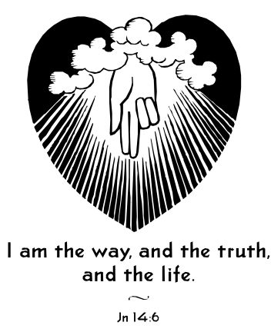
Risen Lord, your resurrection brought joy to all believers,
-give joy to those who live in sadness.
Risen Lord, your resurrection brought hope to all believers,
-give hope to those who live in despair.
Risen Lord, your resurrection formed a community of believers,
-give us true love for one another.
Risen Lord, you are one with your Church on earth,
-hear our prayers for all those in need.

Amen.

FEAST OF SAINT LOUISE DE MARILLAC
May 9
Gospel: (Matthew 25: 31-46)
The King will say to those on his right hand, “Come, you whom my Father has blessed, take for your heritage the kingdom prepared for you since the foundation of the world. For I was hungry, and you gave me food; I was thirsty and you gave me drink; I was a stranger and you made me welcome; naked and you clothed me, sick and you visited me…I tell you solemnly, in so far as you did this to one of the least of these brothers and sisters of mine, you did it to me.”
Reflection:
Louise de Marillac, (1591-1660), married Antoine LeGras and they had a son whom they named Michel, but at the age of 34 she became a widow. Vincent de Paul became her spiritual director and under his guidance she began caring for the poor and visiting the Confraternities of Charity. Vincent and Louise co-founded the Company of the Daughters of Charity, and dedicated them to serve the poor with humility, simplicity and charity. In 1960, Pope John XXIII proclaimed Louise the patron saint of all Christian social workers.
Vincentian Meditation:
“Above all, be very gentle and courteous toward your poor. You know that they are our masters and that we much love them tenderly and respect them deeply. It is not enough for these maxims to be in our minds; we must bear witness to them by our gentle and charitable care.” -St. Louise de Marillac- (Gibson and Kneaves, Praying with Louise, p. 72)
Discussion: (Share your thoughts after a moment of silence)
Share the ways that you see the poor being served today in the spirit of Louise-in gentleness… loving them tenderly and respecting them deeply?
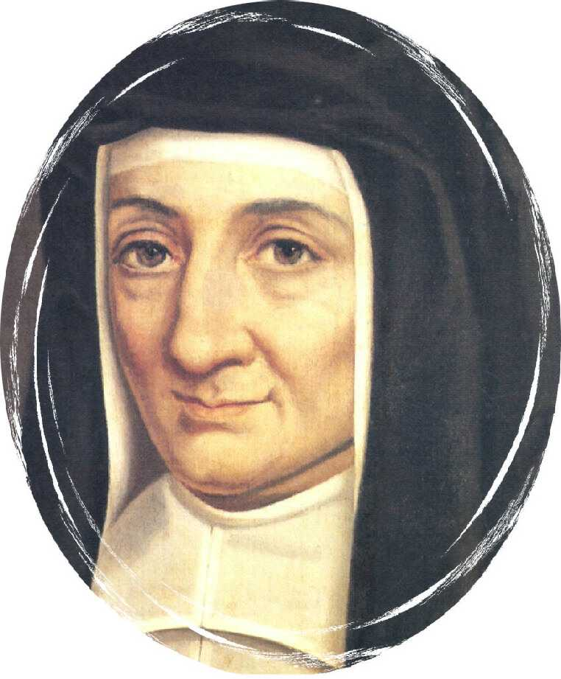
Closing Prayer:
Compassionate Christ, Louise ministered to the needs of your people,
-give us courage to walk in her footsteps.
Suffering played a painful part in Louise’s growth in holiness,
-give us eyes of faith to see Your presence in our suffering.
Louise’s heart was fashioned through her friendship with Vincent,
-give us friends whose love transforms our hearts to love you more.
You inspired Louise with a great love for the poor and the abandoned,
-grant us the grace to serve those whose lives touch ours with the same spirit of love and courage.
May the Vincentian Family continue to grow and multiply throughout the world,
-so that the poor will know God’s love in a tangible way.
Amen

SIXTH SUNDAY OF EASTER
May 10, 2026
Gospel: (John 14:15-21)
Jesus said to his disciples: “If you love me, you will keep my commandments. And I will ask the Father, and he will give you another Advocate to be with you always, the Spirit of truth, whom the world cannot accept, because it neither sees nor knows him. But you know him, because he remains with you, and will be in you. I will not leave you orphans; I will come to you. In a little while the world will no longer see me, but you will see me, because I live and you will live. On that day you will realize that I am in my Father and you are in me and I in you. Whoever has my commandments and observes them is the one who loves me. And whoever loves me will be loved by my Father and I will love him and reveal myself to him.
Reflection:
Jesus tells us that we keep God’s commandments because our love for God has established a deep and intimate relationship between us and God that spills out in acts we know will be pleasing to the Beloved. Rather than burdensome laws, then, commandments are concrete expressions of our love for God and each other. On our own it is impossible either to know God or love God, and that is why Jesus promises us the Spirit will come. If we wish to grow into our love for God we must become attentive to the Spirit who dwells within us. We get to know the Spirit within us by being faithful to prayer, finding the presence of God within, realizing his goodness and cultivating grateful hearts. (Living Liturgy, P.138)
Vincentian Meditation:
“Upon awakening, may my first thoughts be of God. May I make acts of adoration, thanksgiving and abandonment of my will to His most holy will. Reflecting on my lowliness and powerlessness, I shall invoke the grace of the Holy Spirit in which I shall have great confidence for the accomplishment of His will in me, which shall be the sole desire of my heart. (Gibson and Kneaves, Praying with Louise, pp. 50-51)
Discussion: (Share your thoughts on the readings after a moment of silence)
In what ways have we seen the Holy Spirit leading, guiding and protecting us?
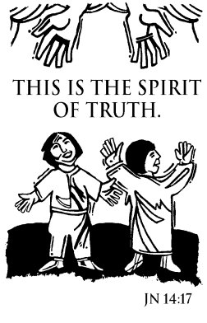
Closing Prayer:
Lord, make us attentive to your Spirit dwelling within us, as we seek to do your will:
When we are weighed down by burdens,
Send us your Spirit!
When we have difficult choices to make,
Send us your Spirit!
When we need hope and peace,
Send us your Spirit!
When we forget your presence among us,
Send us your Spirit!
Amen.
THE ASCENSION OF THE LORD
May 17, 2026
Gospel: (Matthew 28:16-20)
The eleven disciples went to Galilee, to the mountain to which Jesus had ordered them. Then they saw him, they worshiped, but they doubted. Then Jesus approached and said to them, “All power in heaven and earth has been given to me. Go, therefore, and make disciples of all nations, baptizing them in the name of the Father, and of the Son, and of the Holy Spirit, teaching them to observe all that I have commanded you. And behold, I am with you always, until the end of time.”
Reflection:
Jesus knew that his mission was not to be continued by mere humans; on our own authority and power we could not give true witness and our doubts and misunderstandings could never be overcome. Jesus knew that his mission could be entrusted to his disciples because they “will receive power when the Holy Spirit comes upon” them. It is the Spirit who resolves doubt, clears up misunderstanding about the mission, gives wisdom, revelation, and knowledge. Thus, being disciples of Jesus is not something we are alone. We are disciples by letting the Spirit work through us as we live our everyday life. (Living Liturgy, p.142)
Vincentian Meditation:
Vincent said to his priests: “…that we should be called to associate with, and to share in, the works of the Son of God surpasses our understanding. What! To render ourselves -I do not dare say it- so great, so sublime, it is to preach the gospel to the poor, for it is above all else the office of the Son of God, and we are applied to it as instruments by which the Son of God continues to do from heaven what he once did on earth. Great reason have we…to praise God and to thank him unceasingly for this grace!” (McKenna, Praying with Vincent, p. 53)
Discussion: (Share your thoughts on the readings after a moment of silence)
Recall a time when you felt the presence of the Spirit in your life making you an instrument of God.
Closing Prayer:
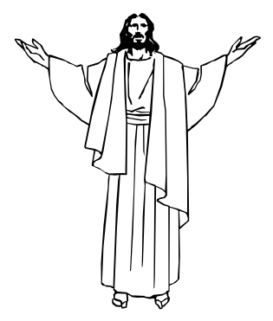
We see the poor all around us and we long to respond to their needs, and so we pray:
-Spirit of God, fill us with your power.
The hungry search for sustenance of body and spirit,
-may we empty ourselves to reach out to them.
Many children are abused or live in poverty and fear,
-may we be advocates for all those who feel unprotected.
Victims of violence cry out for justice,
-may we hear their cries and work for change.
For the grace of being called to serve the poor,
-we give you thanks and praise!
Amen
PENTECOST SUNDAY
May 24, 2026
Gospel: (John 20: 19-23)
On the evening of that first day of the week, when the doors were locked, where the disciples were, for fear of the Jews, Jesus came and stood in their midst and said to them, “Peace be with you.” When he had said this to them, he showed them his hands and his side. The disciples rejoiced when they saw the Lord. Jesus said to them again, “Peace be with you. As the Father has sent me, so I send you.” And when he had said this, he breathed on them and said to them, “Receive the Holy Spirit. Whose sins you forgive are forgiven them, and whose sins you retain are retained.”
Reflection:
Pentecost brings Jesus’ ministry to a focus: we are sent to continue Jesus’ ministry, armed with the Holy Spirit and specific instructions as to what we are to do: forgive. By his ascending into heaven and sending the Holy Spirit Christ makes his mission our mission. It is a great miracle that God chooses to make us real participants in God’s plan of salvation and sharers in God’s divine life. To forgive doesn’t mean to forget; it means to restore love. This is the ministry for which the Spirit empowers us, and this is how we can live in peace. (Living Liturgy, p.150)
Vincentian Meditation:
In his last days, Frederic… “would lie silent for hours with the Bible open by his side. One evening he lay thus, watching the sun sinking into the blue Mediterranean; his wife had drawn her chair a little behind him,…something in the extreme serenity of his countenance prompted her to ask which of all the gifts of God he considered the greatest. He replied without hesitating,… ‘Peace of heart; without this we may possess everything and yet not be happy; with it we can bear the hardest trials and the approach of death.’” (Ramson, Praying with Frederic, p.113)
Discussion: (Share your thoughts on the readings after a moment of silence)
When have we come to know the “Peace of heart” that comes from forgiving and being forgiven?
Closing Prayer:
We are temples of the Holy Spirit, carrying within us the power of God, so we pray:

-Spirit of God, show us the way.
When we find it hard to forgive others,
-Spirit of God, show us the way.
When we search for peace of heart,
-Spirit of God, show us the way.
When we meet the broken-hearted,
-Spirit of God, show us the way.
Amen

THE SOLEMNITY OF THE MOST HOLY TRINITY
May 31, 2026
Gospel: (John 3: 16-18)
God so loved the world that he gave his only Son, so that everyone who believes in him might not perish but might have eternal life. For God did not send his Son into the world to condemn the world but that the world might be saved through him. Whoever believes in him will not be condemned, but whoever does not believe has already been condemned, because he has not believed in the name of the only Son of God.
Reflection:
Of all the festivals on the liturgical calendar, this is the one that speaks most to us of pure, unfathomable mystery. We can only know something of God through what God has done for us and how God relates to us-these are the concrete traces of God among us. This solemnity reminds us that God does not exist in isolation but as a community of Persons in relationship to each other. The Trinity is a relational God who gives and loves. Do we choose to live an independent existence or a Trinitarian, communitarian, and self-giving way of living? The only way to living the kind of community the Trinity models for us is through love, the self-giving love that creates and sustains life. (Living Liturgy, p. 156)
Vincentian Meditation:
St. Vincent prayed: “O my God, may it please you to be the bond which ties the hearts of evangelizers together in a common attitude of humility, of unity, and of respect for one another…Let the good effects of their mutual affection, which you allow to develop among them, steadily grow and flourish, and make the fruits of their labors for the salvation of souls constantly increase. Strengthen them in their efforts, and be yourself their ultimate reward.” (McKenna, Praying with Vincent, p. 107)
Discussion: (Share your thoughts on the readings after a moment of silence)
Within our conference, does the bond which ties our hearts together produce a common attitude of humility, of unity and of respect for one another?
Closing Prayer:
O Holy Trinity, three Persons in one, we pray,
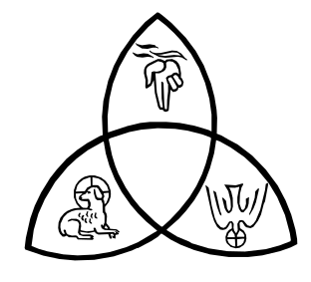
-keep us in the circle of your love.
For all peoples of the earth, created in God’s image,
-may we work toward reconciliation and peace.
For married couples, parents, and children,
-may their mutual love be a reflection of your love.
For all of us gathered together,
-may our love and service bear witness to God’s care.
For all who share in the faith of the Catholic Church,
-may we grow in unity, peace and truth.
Amen

THE MOST HOLY BODY AND BLOOD OF CHRIST
June 7, 2026
Gospel: (John 6: 51-58)
Jesus said to them, “Amen, Amen I say to you, unless you eat the flesh of the Son of Man and drink his blood, you do not have life within you. Whoever eats my flesh and drinks my blood has eternal life, and I will raise him on the on the last day. For my flesh is true food, and my blood is true drink. Whoever eats my flesh and drinks my blood remains in me and I in him. Just as the living Father sent me and I have life because of the Father, so also the one who feeds on me will have life because of me. This is the bread that came down from heaven.
Reflection:
In the mystery of the Eucharist self-giving and community are inseparable. Life is the most precious possession any one of us has. To share one’s life, then, is to share with another our deepest being. Community is the commingling of life through mutual self-giving. Jesus’ gift of life to us through our participation in his Body and Blood is not simply for our own sakes, but for the sake of others. To receive this gift of life is to be compelled to give this gift to others. Eucharist nourishes us and gives us the strength to choose self-giving as a way of living and this is the only way to achieve eternal life. No wonder we call ourselves a Eucharistic people! (Living Liturgy, p.160)
Vincentian Meditation:
St. Louise prayed: “Give Yourself entirely to me, my God. May Your precious body, Your holy soul, and Your glorious divinity, which I adore in this Holy sacrament, take complete possession of me. Sweet Jesus! Gentle Jesus! My God and my All! Have mercy on all souls redeemed by Your precious blood. Inflame them with the arrow of Your love in order to make them grateful for the love that urged You to give Yourself to us in the Blessed Sacrament.” (Gibson and Kneaves, Praying with Louise, p. 59)
Discussion: (Share your thoughts on the readings after a moment of silence.)
In what ways can we become “Eucharistic people?”
Closing Prayer:
Christ Jesus, we give thanks with broken bread and cup of blessing,
-may your food strengthen us for our journey.
Christ Jesus, your Eucharist is a sign of love,
-may the poor and outcasts find a place at your table.
Christ Jesus, your Eucharist is a sign of unity,

-may we embrace diversity with reverence and open hearts.
Christ Jesus, you are the bread that fills the longing of our hearts,
-may this bread deepen our longing for justice,
Christ Jesus, your are the wine that satisfies our thirst for holiness,
-may this wine deepen our desire for You.
Amen
THE MOST SACRED HEART OF JESUS
June 12, 2026
Gospel: (1John 4:7-16)
Beloved, let us love one another, because love is of God; everyone who loves is begotten by God and knows God. Whoever is without love does not know God, for God is love. In this way the love of God was revealed to us: God sent his only Son into the world so that we might have life through him. In this is love: not that we have loved God, but that he loved us and sent his Son as expiation for our sins. Beloved, if God so loved us, we also must love one another. No one has ever seen God. Yet if we love one another, God remains in us, and his love is brought to perfection in us.
Reflection:
The human heart is a symbol for the life, love and well-being of an individual. The heart therefore as a symbol tries to capture God’s tremendous love for us, God’s constant care, and the security we find in resting against God’s heart in prayer. The Sacred Heart tells us “not that we love God, but that he loves us.”
Vincentian Reflection:
Frederic wrote: “Love possesses something of the divine nature, which gives itself without diminishing, which shares itself without division, which multiplies itself, which is present in many places at once, and whose intensity is increased in the measure that it gains in extension. In your wife you will first love God…You will draw comfort from her tenderness on bad days, you will find courage in her example in perilous times, you will be her guardian angel, she will be yours.” (Ramson, Praying with Frederic, p.63)
Discussion: (Share your thoughts on the readings after a moment of silence.)
Frederic found his vocation, his primary commitment in life, in marriage where he found the love of God. How have you found the love of God reflected to you?
Closing Prayer: (Together)
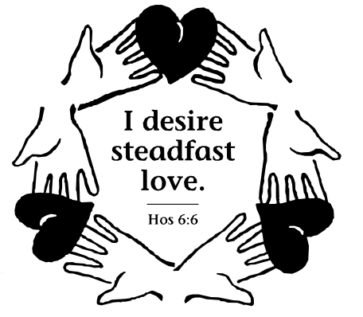
Lord Jesus, we dedicate and consecrate to Your divine Person and to Your Sacred Heart this our Conference (Council) and all the members who compose it, the poor whom we visit in Your name, the youth and children to whom we respond…and all the works we have undertaken in various places for Your Glory… inflame us with that fire which from the depths of Your Heart Thou desire to see burning more and more each day, in order that, filled with the tenderness of Your Heart…we may love and help our neighbor. Give us the grace to live our vocation, loving our spouse, family and others in the example of Frederic and Amelie.
Amen

ELEVENTH SUNDAY IN ORDINARY TIME
June 14, 2026
Gospel: (Matthew 9: 36-10:8)
At the sight of the crowds, Jesus’ heart was moved with pity for them because they were troubled and abandoned, like sheep without a shepherd. Then he said to his disciples, “The harvest is abundant, but the laborers are few; so ask the master of the harvest to send out laborers for his harvest.” Then he summoned his twelve disciples and gave them authority over unclean spirits to drive them out and to cure every disease and every illness…Jesus sent out these twelve after instructing them thus, “…As you go, make this proclamation: ‘The Kingdom of heaven is at hand.’ Cure the sick, raise the dead, cleanse lepers, drive out demons. Without cost you have received; without cost are you to give.”
Reflection:
The mission of Jesus’ disciples is to reach out to others with the same compassion as Jesus had, a gift of God. Compassion is the wellspring for ministry. The urgency of divine compassion teaches us that our ministry is one of mercy and charity. There are always people “without a shepherd”: the teen who needs an adult to guide them along right paths, the lost traveler who asks for a bit of our time, young children who are looking for companionship and guidance, he coworker who needs a listening ear, the spouse who needs our gratitude and love, the homeless who is cold, the single parent who needs support and food for their family. (Living Liturgy, p.172)
Vincentian Meditation:
“Whenever I happened to speak abruptly to the convicts, I spoiled everything. But whenever I praised them for their acceptance and showed them compassion, whenever I sympathized with them in their sorrows, when I kissed their chains and showed how upset I was when they were punished, then they always listened to me and even turned to God.” (McKenna, Praying with Vincent, p.96)
Discussion: (Share your thoughts on the readings after a moment of silence.)
Recall some instance when you were gentle and compassionate with someone when you could have been angry.
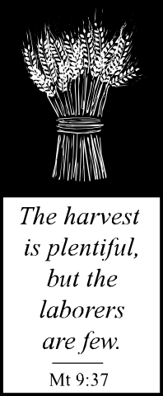
Closing Prayer:
O God, you inspire the followers of Vincent to be compassionate in their service,
-help us to serve always with respect and gentleness.
You reveal yourself to us in the person of the poor,
-assist us as we strive to learn the lessons they can teach us.
By their presence, the poor invite us to accompany them in their struggles,
-give us a heart that is filled with kindness and understanding.
Modeling your example of mission and ministry,
-send us out in humility, simplicity and charity.
Amen

TWELFTH SUNDAY IN ORDINARY TIME
June 21, 2026
Gospel: (Matthew 10:26-33)
Jesus said to the Twelve: “Fear no one…And do not be afraid of those who kill the body but cannot kill the soul; rather, be afraid of the one who can destroy both soul and body in Gehenna. Are not two sparrows sold for a small coin? Yet not one of them falls to the ground without your Father’s knowledge. Even all the hairs of your head are counted. So do not be afraid; you are worth more than many sparrows. Everyone who acknowledges me before others I will acknowledge before my heavenly Father. But whoever denies me before others, I will deny before by heavenly Father.
Reflection:
The gospel speaks of the fear that the disciples would have in facing opposition. When we are compassionate—sent out to serve the poor—we also will face opposition and persecution. This doesn’t mean censorship or physical hardship only. It does mean that our lives must embody the care and compassion of God. The mission of discipleship ought not be undertaken lightly, because there will also be persecution. Neither, however, ought the mission be undertaken with trepidation because God does not abandon us. (Living Liturgy, p.176)
Vincentian Meditation:
Vincent often cautioned against “undisciplined enthusiasm,” a false zeal that springs from desire for praise or from anger. Unlike true zeal, compulsions take on a hard edge of self-righteousness or paralyzing preoccupation with self: what I do, rather than what God wants done. True zeal sets a person on fire with love of God, with the realization that all gifts and all power come from God. Thus, true zeal is humble but courageous in the face of scorn and persecution. True zeal acts with charity, not out of a desire to manipulate, or out of trendy do-goodism. Christian zeal models itself on Jesus’ zeal to proclaim the Good News of God’s love and to heal the wounds of suffering people. (McKenna, Praying with Vincent, p.92)
Discussion: (Share your thoughts on the readings after a moment of silence.)
When have we seen “true zeal” in our Conference?
Closing Prayer:
O God, you inspire Vincentians to have zeal in their service,
-help us to serve always with respect and gentleness.
O God, you send us to serve the poor and the suffering,
-help us to face opposition and persecution.
O God, you told us that you will acknowledge us before your heavenly Father,

-help us to acknowledge you before others.
O God, you told us to not be afraid,
-help us to know that you are always with us.
Amen

THIRTEENTH SUNDAY IN ORDINARY TIME
June 28, 2026
Gospel: (Matthew 10:37-42)
Jesus said to his apostles: “Whoever loves father or mother more than me is not worthy of me, and whoever loves son or daughter more than me is not worthy of me; and whoever does not take up his cross and follow after me is not worthy of me. Whoever finds his life will lose it, and whoever loses his life for my sake will find it. Whoever receives you receives me, and whoever receives me receives the one who sent me….And whoever gives only a cup of cold water to one of these little ones to drink because the little one is a disciple—amen, I say to you, he will surely not lose his reward.”
Reflection:
The heart of the paschal mystery is dying and rising. Our own daily living can sometimes seem to have much more dying than rising. Even setting aside the issue of consciously choosing self-sacrifice, just the simple demands of our lives pull it out of us: feeding the infant in the middle of the night, ferrying the kids to soccer, helping with the homework when we are dog tired, cleaning the house and preparing meals, taking time to share some good thing with a spouse, calling and visiting an aging parent, helping the suffering and the poor. One of the great encouragements of this Sunday’s gospel is that all this behavior—like giving “a cup of cold water”—may seem small to us, but to God they are actions that correspond to those of Christ. The message is that our generosity is far surpassed by God’s generosity. (Living Liturgy, p.188)
Vincentian Meditation:
To Vincent, a life of virtue was no accident. God gives the grace, but human effort is required to cultivate the virtue. Habits of charity, hopefulness, and justice are built, not just wished into being. Vincent knew that good intentions were insufficient responses to God’s grace. Virtue—a good habit, an inner readiness to accomplish moral good—had to become part of the fabric of life. For instance, by acting patiently over and over in trying situations, a person may learn patience. Virtues such as patience are important in the full living of the Christian life. Vincent constantly made concrete suggestions about how to develop virtue. From hard experience, he knew that definite dispositions had to be cultivated into the heart of the servant if the Gospels were to come alive through his or her hands. (McKenna, Praying with Vincent, p.70)

Discussion: (Share your thoughts on the readings after a moment of silence.)

What Vincentian virtues have you seen lived out in your Conference?
Closing Prayer:
O God, you inspire the followers of Vincent to be virtuous,
-help us to serve always with respect and gentleness.
O God, you inspire the followers of Vincent to be servants of the poor,
-send us out in humility, simplicity and charity.
Amen
REFERENCES:

Gibson, Audrey DC and Kieran Kneaves DC, Praying with Louise de Marillac, Saint Mary’s Press, Winona, Minnesota,1995.

*Maloney, Robert CM. Seasons in Spirituality: Reflections on Vincentian Spirituality in Today’s World, New City Press, Hyde Park, New York, 1998.

*Father Robert Maloney was born and raised in Brooklyn, New York. He was the Superior General of the Congregation of the Mission and the Daughters of Charity, and of the Vincentian Family from 1992-2004.

**McCullen, Richard CM. Deep Down Things, New City Press, Hyde Park, New York 1995.
** Father Richard McCullen from Ireland, was the Superior General of the Congregation of the Mission and the Daughters of Charity, and of the Vincentian Family from 1980-1992.

McKenna, Thomas CM. Praying with Vincent de Paul, Saint Mary’s Press, Winona, Minnesota, 1994.

Ramson, Ronald CM. Praying with Frederic Ozanam, Saint Mary’s Press, Winona, Minnesota, 1998.

Zimmerman, Joyce Ann C.PP.S. et al. Living Liturgy, The Liturgical Press, Collegeville, Minnesota, 2002.

Clip Art: Liguori Publications, Faithware – Cycle A, Liguori, Missouri, 1998.

For information contact:
Timothy P. Williams
Society of St. Vincent de Paul

Council of the United States
66 Progress Parkway
St. Louis, MO 63043-3706
Phone: 314-576-3993
E-MAIL: twilliams@svdpusa.org

Copyright: January 2004-The Society of St. Vincent de Paul Council of the United States.



The Vincentian Weekly Reflections have been developed exclusively for use by the Society of St. Vincent de Paul and the Vincentian Family. They cannot be reproduced in any form without the expressed consent of the National Council of the Society of St. Vincent de Paul.

