VINCENTIAN REFLECTIONS
First Quarter 2026



Liturgical Year: A

(January—February—March)

Available on SSVPUSA.org



HOW TO LEAD THE VINCENTIAN REFLECTIONS IN A CONFERENCE

INTRODUCTION:
Leader describes to the group the process which is going to take place:
- Provide a copy for each member of your Conference for their personal reflection
- Stress that sharing is not compulsory and mention the need for confidentiality
- Ask, or assign, different members to read the different sections:
-Gospel reading
-Reflection
-Vincentian Meditation

OPENING PRAYER/QUIETING DOWN PERIOD
Leader invites group to:
- Become relaxed and aware of God’s presence with us
- “Let Go” of distractions and quietly pray to the Holy Spirit

READING OF THE VINCENTIAN WEEKLY REFLECTION
- Each section is read aloud, slowly and prayerfully, by the different members
- Hearing different voices will allow different emphasis on words/phrases

QUIET PERIOD
Leader invites everyone:
- To quietly reflect on the readings and notice if anything strikes them
- Introduces the Discussion Question suggested in the Reflection
- Allows 2-3 minutes of quiet – don’t hurry this. God speaks to us in the silence.

SHARING
Leader invites members who wish to share on the Discussion Question, or on how
the one of the readings struck them. Possibly not everyone will share, but time should be allowed for each person who wishes to share his/her thoughts. It is important that you resist the urge either to prod members to share, or to try to “fill the silence” with your own thoughts.

CLOSING PRAYER
Leader closes the Prayer Reflection by beginning the Closing Prayer, and all answer the response (in bold).

(This entire process should take about 10-15 minutes)
INTRODUCTION
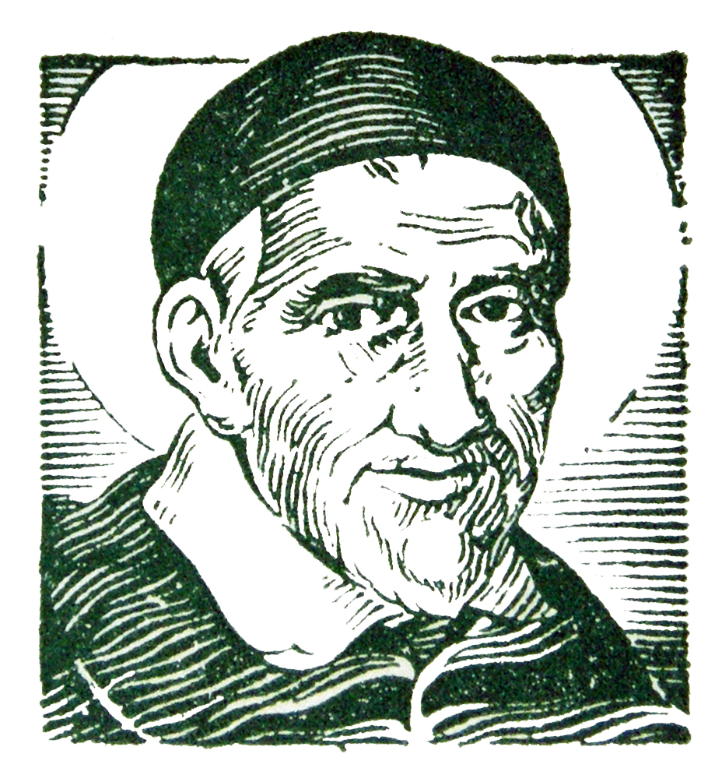
St. Vincent de Paul never wrote a book about his spiritual teachings. But we find the living voice of the saint in his letters and conferences in which he trained his followers for the mission of service to the poor.

The two fundamental sources of his teaching are the GOSPEL and LIFE. He wanted his followers to put the whole of the Gospel into the whole of their lives, and he never wearied of deepening both with all the faith that God had put into his heart. That is why all that Vincent says to us has the simplicity of our everyday life and the penetrating strength of the Word of God.

The Vincentian Weekly Reflections are therefore offered to all who strive to serve the poor in the spirit of St. Vincent de Paul. The prayer and reflections are based on the Sunday Gospel of the Liturgical Calendar, together with the feast days of some of the saints of our Vincentian Family. Each reflection offers a time for prayer, silence and discussion so that our everyday life, like Vincent, can become penetrated with the strength of the Word of God.

You may want to run copies for each member of your Conference so that they may take them home for personal reflection during the week.



LITURGICAL YEAR A
First Quarter - 2026

JANUARY

January 1 Solemnity of the Blessed Virgin Mary, Mother of God
January 4 Epiphany of the Lord
January 11 Baptism of the Lord
January 18 Second Sunday in Ordinary Time
January 25 Third Sunday in Ordinary Time

FEBRUARY

February 1 Fourth Sunday in Ordinary Time
February 7 Feast of Blessed Rosalie Rendu
February 8 Fifth Sunday in Ordinary Time
February 15 Sixth Sunday of Ordinary Time
February 18 Ash Wednesday
February 22 First Sunday of Lent

MARCH

March 1 Second Sunday of Lent
March 8 Third Sunday of Lent
March 15 Fourth Sunday of Lent
March 22 Fifth Sunday of Lent
March 29 Palm Sunday

SOLEMNITY OF THE BLESSED VIRGIN MARY, MOTHER OF GOD
January 1, 2026
Gospel: (Luke 2:16-21)
The shepherds went in haste to Bethlehem and found Mary and Joseph, and the infant lying in a manger. When they saw this, they made known the message that had been told them about this child. All who heard it were amazed by what had been told them by the shepherds. And Mary kept all these things, reflecting on them in her heart. Then the shepherds returned, glorifying and praising God for all they had heard and seen, just as it had been told to them. When eight days were completed for his circumcision, he was named Jesus, the name given him by the angel before he was conceived in the womb.
Reflection:
Like the shepherds, we wish to remember the incarnation event “glorifying and praising God” and with Mary we “keep these things, reflecting on them in our hearts.” Like Mary, we must assume a contemplative stance toward God’s marvelous deeds of salvation. God revealed the divine will and plan to Mary for her part in the plan of salvation; she responded with a yes that she contemplated throughout her life. Christmas reveals God’s will for our salvation and asks of us our contemplative yes. When we wish each other “Happy New Year” as Christians, we are really wishing each other a grace-filled year of responding to God’s revelation and a year of contemplating what we have seen and heard so that we can come to understand life with more depth and insight. May our “Happy New Year” be a pledge to, like the shepherds and Mary, embrace in joy and peace God’s presence to us and in us. (Living Liturgy, p.32)
Vincentian Meditation:
“Give me a man of prayer and he will be capable of anything. He may say with the apostle, ‘I can do all things in him who strengthens me.” St. Vincent de Paul (McKenna, Praying with Vincent, p. 110)
Discussion: (Share your thoughts after a moment of silence)
How have you discovered that as Vincentians we are called to be “contemplatives in action”?
Closing Prayer:

Mary, you who are the Mother of God, we now pray:
-teach us how to be contemplatives in action.
Mary, wellspring of peace,
-be our fountain of grace.
Mary, model of risk,
-help us overcome our fears.
Mary, mother of the poor,
-give us compassion in our service
Amen

THE EPIPHANY OF THE LORD

January 4, 2026
Gospel: (Matthew 2:1-12)
When Jesus was born in Bethlehem in Judea, in the days of King Herod, behold, magi from the east arrived in Jerusalem, saying, “Where is the newborn king of the Jews? We saw his star at its rising and have come to do him homage.” When King Herod heard this, he was greatly troubled, and all Jerusalem with him. …Herod sent them to Bethlehem and said, “Go and search diligently for the child…” After their audience with the king they set out. And behold, the star that they had seen at its rising preceded them, until it came and stopped over the place where the child was. They were overjoyed at seeing the star, and on entering the house they saw the child with Mary his mother. They prostrated themselves and did him homage. Then they opened their treasures and offered him gifts of gold, frankincense, and myrrh. And having been warned in a dream not to return to Herod, they departed for their country by another way.
Reflection:
The magi followed the light and found the Savior of the world. The magi searched, encountered, worshiped him and offered gifts. The magi demonstrated how Christianity must always show “faith in action.” Believing always plays itself out in living. The pattern of our lives is that of the magi: seek, encounter, homage, self-giving. An important lesson here for living is that authentic homage (worship) naturally leads to living in the Light. Worship, then, is more than what happens in church on Sunday. It is the light of our own selves that shines throughout our weekdays, witnessing to our own encounters with the Light. Our very lives must proclaim our faith. (Living Liturgy, p.36)
Vincentian Meditation:
“This is my prayer to you, O Lord! Give to me your special favor. Pour out your truth and mercy on me in an abundance that will enable me to put your love into practice, filling me with true affection for you, for my neighbor, and also for myself.” -St. Vincent de Paul- (McKenna, Praying with Vincent, p.113)
Discussion: (Share your thoughts after a moment of silence)
How does the “light of our own selves” shine throughout our weekdays?
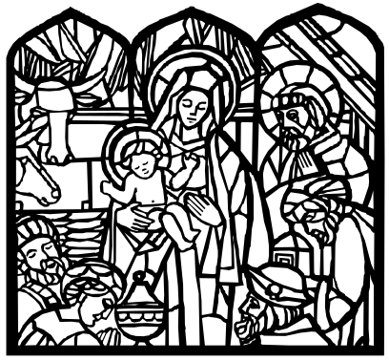
Closing Prayer:
O God, as you guided the Magi by the light of a star,
-may Jesus be our light.
O God, you have created a marvelous variety of peoples,
-may we be open to all cultures, races, and nations.
O God, your love surrounds us,
-may we faithfully offer Christ the gold of living faith, the incense of our worship, and the myrrh of compassion.
Amen

THE BAPTISM OF THE LORD
January 11, 2026
Gospel: (Matthew 3:13-17)
Jesus came from Galilee to John at the Jordan to be baptized by him. John tried to prevent him, saying, “I need to be baptized by you, and yet you are coming to me?” Jesus said to him in reply, “Allow it now, for thus it is fitting for us to fulfill all righteousness.” Then he allowed him. After Jesus was baptized, he came up from the water and behold, the heavens were opened for him, and he saw the Spirit of God descending like a dove and coming upon him. And a voice came from the heavens, saying, “This is my beloved Son, with whom I am well pleased.
Reflection:
At his baptism the heavens were opened and the Spirit descended upon Jesus, anointing him as Messiah. Thus anointed, he was enabled to “fulfill all righteousness”, to bring forth justice to the nations: he makes the blind see, gives prisoners freedom, brings light to those dwelling in darkness, went about doing good and healing all those oppressed. The voice from heave revealed to Jesus his identity and a mission that called forth a response-his life of preaching, teaching, healing, forgiving, etc. This same identity and mission is revealed to us, and calls forth from us the same faithful response. This is our Christian and our Vincentian life. (Living Liturgy, p.40)
Vincentian Meditation:
“Blessed are those persons who, under the guidance of Divine Providence, are called upon to continue the ordinary practices of the life of the Son of God through the exercise of charity.” -St. Louise de Marillac- (Gibson and Kneaves, Praying with Louise, p. 36)
Discussion: (Share your thoughts after a moment of silence)

How has Divine Providence called us to carry on the mission of Jesus?

Closing Prayer:
The heavens are opened and the Spirit of God comes to rest upon Jesus,
-Spirit of God, rest upon us
Christ, the Chosen, you trusted in the loving plan of God,
-deepen our faith in the Providence of God
Christ, the Anointed, you began your public ministry after your baptism,
-may we serve all we meet today with compassion, cordiality and respect.
Christ, the Beloved, you emptied yourself in love for the human family,
-open our hearts to the poorest and most abandoned
Amen

SECOND SUNDAY IN ORDINARY TIME

January 18, 2026
Gospel: (John 1:29-34)
John the Baptist saw Jesus coming toward him and said, “Behold, the lamb of God, who takes away the sins of the world. He is the one of whom I said, ‘A man is coming after me who ranks ahead of me because he existed before me.’ I did not know him, but the reason why I came baptizing with water was that he might be made known to Israel.” John testified further, saying, :I saw the Spirit come down like a dove from heaven and remain upon him. I did not know him, but the one who sent me to baptize with water told me, ‘On whomever you see the Spirit come down and remain, he is the one who will baptize with the Holy Spirit.’ Now I have seen and testified that he is the Son of God.”
Reflection:
Our baptismal task is continually to deepen our own understanding of who Jesus is and to make him known. We don’t come to a one-time understanding of Christ. Our whole lives are spent beholding the Lamb of God. Like John, we go from not knowing to seeing to testifying. More than likely, we aren’t called to testify to the Son of God by going and baptizing or doing great things. We testify to Jesus’ identity by being faithful to the ordinary things in life, by doing God’s will. The revelation of Jesus’ identity—how he is made known in the world—is mediated by the way we live our lives everyday.
Vincentian Meditation:
The fields of battle for Frederic Ozanam were not only the arenas of the poor, but also the milieus of the young whom he served at the university. One day he heard that the public were clamoring for him at the Sorbonne, accusing him of self-indulgence and neglect of duty in being so long absent from his course, when he was paid by the State for giving it. The news stung him to the quick. “I will show them it is not true. I will do honor to my profession!” Bl. Frederic Ozanam (Ramson, Praying with Frederic, p. 102)
Discussion: (Share your thoughts after a moment of silence)
In what ways have you testified to Jesus’ identity by being faithful to the ordinary things in life, like Frederic?

Closing Prayer:
Jesus, in the waters of the Jordan, you were consecrated as God’s Beloved, and now we pray,
-Spirit of God, fill us with zeal.
You call us to be people of courage,
-Jesus, send forth your spirit of freedom.
You call us to consecrate ourselves to the poor,
-Jesus, send forth your spirit of love.
You call us to bind up the wounds of the brokenhearted,
-Jesus, send forth your spirit of healing.
Amen

THIRD SUNDAY IN ORDINARY TIME
January 25, 2026
Gospel: (Matthew 4:12-23)
When Jesus heard that John had been arrested, he withdrew to Galilee. …From that time on, Jesus began to preach and say, “Repent, for the kingdom of heaven is at hand.” As he was walking by the Sea of Galilee, he saw two brothers, Simon who is called Peter, and his brother Andrew, casting a net into the sea; they were fishermen. He said to them, “Come after me, and I will make you fishers of men.” At once they left their nets and followed him. He walked along from there and saw two other brothers, James, the son of Zebedee, and his brother John. They were in a boat, with their father mending nets. He called them, and immediately they left their boat and their father and followed him. He went around all of Galilee, teaching in their synagogues, proclaiming the gospel of the kingdom, and curing every disease and illness among the people.
Reflection:
Every encounter with Jesus provokes a response; this gospel shows a response of discipleship that is quick and decisive. Our own call to discipleship comes at our baptism, but unlike the disciples in the gospel our response isn’t usually so quick and decisive. We spend our whole life trying to see the great Light that is the Savior of the world. But we practice the following of Jesus in the simple, everyday things that come our way: the friend who needs a listening ear, the elderly parent who needs a comforting phone call, the sick child who interrupts our sleep. In all of these instances do we hear Jesus’ refrain: repent? Turn from ourselves toward those in need. Turn from darkness to light. (Living Liturgy, p.50)
Vincentian Meditation:
“Lord Jesus, teach me by your example. Make me, through the vigor of my efforts, set the world on fire. I want to give myself to you, body and soul, heart and mind and spirit so that I may always do what gladdens you. In your mercy, grant me the grace to have you continue in me and through me your saving work.” -St. Vincent de Paul-
(McKenna, Praying with Vincent, p.67)
Discussion: (Share your thoughts after a moment of silence)
In what simple, every day things have you heard Jesus’ refrain: repent- turn from yourself and toward those in need?

Closing Prayer:
For the grace to “repent,” turning from ourselves toward those in need,
-Merciful God, hear us!
For the grace to respond to the call of discipleship, quickly and decisively,
-Merciful God, hear us!
For the grace of healing to all who are ill and alone,
-Merciful God, hear us!
Amen
FOURTH SUNDAY IN ORDINARY TIME
February 1, 2026
Gospel: (Matthew 5:1-12)
When Jesus saw the crowds, he went up the mountain, and after he had sat down, his disciples came to him. He began to teach them, saying: “Blessed are the poor in spirit, for theirs is the kingdom of heaven. Blessed are they who mourn, for they will be comforted. Blessed are the meek, for they will inherit the land. Blessed are they who hunger and thirst for righteousness, for they will be satisfied. Blessed are the merciful, for they will be shown mercy. Blessed are the clean of heart, for they will see God. Blessed are the peacemakers, for they will be called children of God.
Reflection:
One way to approach the Beatitudes is in terms of their being descriptions of identity rather than moral demands. The Beatitudes embody a radically alternative vision of our Society. This is how the kingdom of heaven is at hand: that we appreciate that we are in ourselves are blessed. Blessed is who we are in Christ. God indeed calls us to blessedness. (Living Liturgy, p.54)
Vincentian Meditation:
“The gospels and epistles frequently remind Christians to be gentle. They should seek to resolve conflicts peacefully, act with kindness, speak courteously—in short, love their neighbors as they love themselves. Such gentleness comes when Christians realize that despite all their sins, God loves them. The balance of gentleness and strength is learned in the schools of prayer and experience. Gentleness is not passivity or spinelessness. Strength is not uncontrolled rage or stoic coldness. Determining when to be gentle and when to be forceful should be the subject of our prayerful discernment. We are called to be gently strong, and strongly gentle. (McKenna, Praying with Vincent, p.97-98)
Discussion: (Share your thoughts after a moment of silence)
How have you been “gently strong and strongly gentle”?
Closing Prayer:

For the grace to be poor in spirit,
-Merciful God, hear us!
For the grace to mourn ,
-Merciful God, hear us!
For the grace to be meek,
-Merciful God, hear us!
For the grace to hunger and thirst for justice,
-Merciful God, hear us!
For the grace to be merciful,
-Merciful God, hear us!
Amen

FEAST OF BLESSED ROSALIE RENDU
February 7

Gospel: (John 15: 9-17)
Jesus said to his disciples: “As the Father has loved me, so I have loved you. Live on in my love. You will live in my love if you keep my commandments, even as I have kept my Father’s commandments, and live in his love. All this I tell you that my joy may be yours and your joy may be complete. This is my commandment: love one another as I have loved you. There is no greater love than this: to lay down one’s life for one’s friends.
Reflection:
Sister Rosalie Rendu (1786-1856) was a Daughter of Charity of St. Vincent de Paul, who worked for the poor in the Mouffetard district of Paris, France. Her zeal for the poor drove her to establish the means to educate poor children; to care for infants; to support the elderly; to serve the poor in their homes; and to supervise young working girls. One of her disciples in her mission of service was Frederic Ozanam and the first members of the St. Vincent de Paul Society. She gave to them her gift of insight in serving the poor when she told them, “Be kind and love, for love is your first gift to the poor. They will appreciate your kindness and your love more then all else you can bring to them. If you wish to be loved, you must love, and if you have nothing to give, give yourself.”
Vincentian Meditation:
“Always remember, that if our childhood has been one of constant want, perhaps, we too, would have given away to envy and hatred, as I must admit have many of the poor we serve.”-Bl. Rosalie Rendu-
Discussion: (Share your thoughts after a moment of silence)
How do you see the spirit of St. Vincent, as lived by Sister Rosalie and Frederic, alive today?
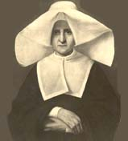
Closing Prayer:
Holy God, we claim your mercy and cry out:
For the poor we serve,
-we ask your help and solace.
Loving Spirit, circle the victims of violence and war,
-protect and guard them.
Provident God, provide what we need to give to the poor,
-and lighten their burdens.
For all the members of the Society of St. Vincent de Paul,
-we ask your blessings and peace.
Amen.

FIFTH SUNDAY IN ORDINARY TIME
February 8, 2026
Gospel: (Matthew 5: 13-16)
Jesus said to his disciples: “You are the salt of the earth. But if salt loses its taste, with what can it be seasoned? It is no longer good for anything but to be thrown out and trampled underfoot. You are the light of the world. A city set on a mountain cannot be hidden. Nor do they light a lamp and then put it under a bushel basket; it is set on a lamp stand, where it gives light to all in the house. Just so, your light must shine before others, that they may see your good deeds and glorify your heavenly father.”
Reflection:
The lights in a city create a glow in the sky that can be seen from miles away. However, a light can be hidden—put under a bushel; the light still shines, but its light is blanketed, covered over, kept from doing what it is meant to do. When Jesus says, “You are the light of the world,” he is saying that we can choose to cover over the grace that is given us. We can choose to ignore who we are called to be—beloved adopted sons and daughters—and act of “out of character.” Then our actions do not square up with who we are. By such choices we compromise both identity and mission. We must live who we are. Identity and mission cannot be separated. (Living Liturgy, p.58)
Vincentian Meditation:
Vincent prayed that over time his designs and actions would be more and more in harmony with God’s desires. He knew that this was the way to a full life. One afternoon in the very last months of his life, Vincent sat with some of his close friends. In the way that people sometimes do when they sense that their time is coming to an end, Vincent began to speak about what mattered to him most. He did not tell of any particularly successful project, or of people whom he had loved and who had loved him, nor even of his precious poor ones. Rather, he talked to his friends about the loving hand of God that had led him, of the interior star that had steered him through all the hectic years. Bent and elderly as he was, he declared, “We should give ourselves to God and wear ourselves out for God.” (McKenna, Praying with Vincent, p.35)
Discussion: (Share your thoughts after a moment of silence)
In what ways is our Conference a “light that shines before others?”
Closing Prayer:
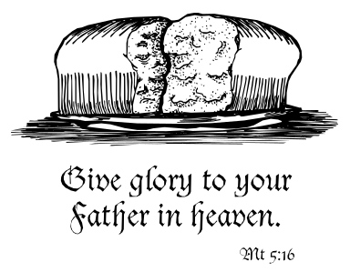
For the grace to be the salt of the earth,
-Loving God, hear us!
For the grace to be a light of the world,
-Loving God, hear us!
For the grace to “give ourselves to God,”
-Loving God, hear us!
For the grace to “wear ourselves out for God,”
-Loving God, hear us!
Amen

SIXTH SUNDAY IN ORDINARY TIME
February 15, 2026
Gospel: (Matthew 5: 17-37)
Jesus said to his disciples: “Do not think that I have come to abolish the law and the prophets. I have come, not to abolish them, but to fulfill them. Of this much I assure you: until heaven and earth pass away, not the smallest letter of the law, not the smallest part of a letter, shall be done away with until it all comes true. …Whoever fulfills and teaches these commands shall be great in the kingdom of God. I tell you, unless your holiness surpasses that of the scribes and Pharisees you shall not enter the kingdom of God.”
Reflection:
Holiness demands that we live who we are…our identity and mission cannot be separated. “Doing” who we are—choosing to let our identity express itself in mission—is lived out in feeding the hungry, sheltering the oppressed and clothing the naked. The Bible in all its parts calls us relentlessly for action on behalf of others. This is a staggering demand, bigger than any individual, and so it is truly a corporate mission undertaken by the community of disciples working together. (Living Liturgy, p.5p)
Vincentian Meditation:
Every Christian at every moment is called to holiness. Make no mistake about it. You are proclaiming a message at every moment of the day, even when you are not speaking. Your message must be authentic. It will be so, if you are authentic. Your authenticity as a Christian comes from your personal relationship with Jesus Christ, truly God and truly man. Often ask your self: “Could Jesus Christ share what I am going to say or what I am going to do?” If you can reply yes, then you are authentic. Holiness can be summed up in the words of Micah (Mi6:8): “God has shown you, O man, what is good; and what does the Lord require of you but to do justice and to love kindness and to walk humbly with your God.”(McCullen, Deep Down Things, p.555)
Discussion: (Share your thoughts after a moment of silence)
In our Conference how are we “doing justice, loving kindness and walking humbly with our God?”

Closing Prayer:
For the grace to do justice,
-Loving God, help us to grow in holiness!
For the grace to love kindness,
-Loving God, help us to grow in holiness!
For the grace to walk humbly with our God,
-Loving God, help us to grow in holiness!
Amen

ASH WEDNESDAY

February 18, 2026
Gospel: (Matthew 6: 1-6, 16-18)
Jesus said to his disciples: “Be on guard against performing religious acts for people to see. When you give alms, for example, do not blow a horn before you in synagogues and streets like hypocrites looking for applause…Keep your deeds of mercy secret, and your Father who sees in secret will repay you. When you are praying, do not behave like the hypocrites…Whenever you pray, go to your room, close the door, and pray to your Father in private. Then your Father, who sees what no man sees, will repay you. When you fast, you are not to look glum as the hypocrites do…When you fast, see to it that you groom your hair and wash your face. In that way no one can see you are fasting but your Father who is hidden; and your Father who sees what is hidden will repay you.”
Reflection:
In the gospel we hear Jesus direct his disciples to surrender their money in alms, their bodies in fasting, and their spirits in prayers. May Jesus gift us with his presence this Lent, so that we can be a gift to others in carrying out our service as we:
Fast from judging others, to feast on the Christ indwelling in them.
Fast from unrelenting pressures, to feast on unceasing prayer.
Fast from self-concern, to feast on compassion for others.
Vincentian Meditation:
“I should not judge the poor peasants, men or women, by their exterior nor by their apparent mental capacities. All the more is this so since very frequently they scarcely seem to have the appearance or intelligence of reasonable beings…But turn the medal, and you will see by the light of faith that the Son of God, whose will it was to be poor, is represented to us by these people.” St. Vincent de Paul (McKenna, Praying with Vincent, p. 59)
Discussion: (Share your thoughts after a moment of silence)
Recall your last encounter with a homeless or poor person. Was it an occasion during which you saw below the surface -you turned the medal- and caught a glimpse of God’s presence?
Closing Prayer:
Lent is the acceptable time for renewing our desire to serve as Jesus served, so we pray:
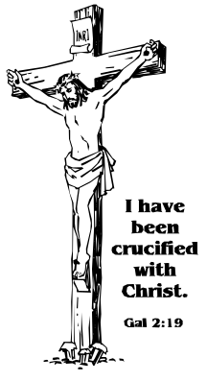
When we walk with those caught in the cycle of poverty-
Help us to see your face, O God!
When we look into the wondering eyes of a child-
Help us to see your face, O God!
When we reach out to the homeless-
Help us to see your face, O God!
When we listen to the fading voice of the aged-
Help us to see your face, O God!
AMEN
FIRST SUNDAY OF LENT

February 22, 2026
Gospel: (Matthew 4:1-11)
At that time Jesus was led by the Spirit into the desert to be tempted by the devil. He fasted for forty days and forty nights, and afterwards he was hungry. The tempter approached and said to him, “If you are the Son of God, command that these stones become loaves of bread.” He said in reply, “It is written: One does not live on bread alone, but on every word that comes forth from the mouth of God.” The devil took him to the city, and made him stand on the parapet of the temple, and said to him, “If you are the Son of God, throw yourself down. …Jesus answered him, “Again it is written, You shall not put the Lord, your God, to the test.” Then the devil took him up to a very high mountain, and showed him all the kingdoms of the world in their magnificence, and he said to him, “All these I shall give you, if you will prostrate yourself and worship me.” At this Jesus said to him, “Get away, Satan! It is written: The Lord, your God, shall your worship and him alone shall you serve.”
Reflection:
We are never immune to temptation; it is real. But temptation always brings choice, decision, and greater self-knowledge. In the case of the Son of God, his choice was also between God and Satan, his decision was to be faithful to God’s Law and revelation, and his greater self-knowledge led him out of the desert to begin his public ministry. In our daily living we must place our temptations and the choices within the context of the commandment to love God and neighbor. This is Lent’s challenge and invitation. (Living Liturgy, p. 64).
Vincentian Meditation:
Frederic Ozanam suffered temptations against his faith, and he was literally brought to his knees. Thanks to a friend, we know that: “In the darkest hour of trial, which had become for him actual pain, the young student appealed to the mercy of God for light and peace. He threw himself on his knees before the Most Blessed Sacrament, and there in tears and in all humility, he promised Our Lord that, if He would deign to make the lamp of truth shine in his sight, he would consecrate his life to its defense.” –Bl. Frederic Ozanam (Ramson, Praying with Frederic, p.50)
Discussion: (Share your thoughts after a moment of silence)
What phrases in Frederic’s words are most significant to you? Share these insights with each other.
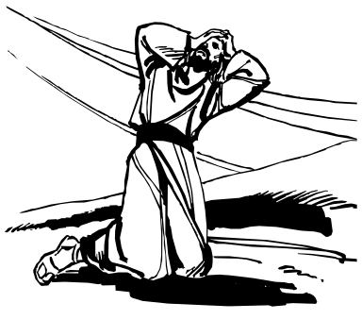
Closing Prayer:
Lord, during this Lent, give us the grace to:
Fast from apparent darkness;
to feast on the reality of light.
Fast from personal anxiety;
to feast on eternal truth.
Fast from discouragement;
to feast on hope.
Fast from temptations;
to feast on prayer and silence.
Amen

SECOND SUNDAY IN LENT

March 1, 2026
Gospel: (Matthew 17:1-9)
Jesus took Peter, James, and John his brother, and led them up a high mountain by themselves. And he was transfigured before them; his face shone like the sun and his clothes became white as light. And behold, Moses and Elijah appeared to them, conversing with him. Then Peter said to Jesus in reply, “Lord, it is good that we are here. If you wish, I will make three tents here, one for you, one for Moses, and one for Elijah.” While he was still speaking, behold, a bright cloud cast a shadow over them, then from the cloud came a voice that said, “This is my beloved Son, with whom I am well pleased; LISTEN TO HIM.” When the disciples heard this, they fell prostrate and were very much afraid. But Jesus came and touched them, saying, “Rise, and do not be afraid.” And when the disciples raised their eyes, they saw one else but Jesus alone.”
Reflection:
Christian living is about being “touched” by Jesus so that the fleeting moments of glory are made permanent in bettering the lives of others. We don’t “build tents”; we feed the hungry, clothe the naked, touch the downhearted, visit the lonely, encourage the discouraged…bringing the tenderness of Christ to all persons who are destitute and forgotten. In this way Christ touches others through us. (Living Liturgy, p. 68)
Vincentian Meditation:
“So very often, many outpourings of affection for God, of resting in his presence, of good feelings toward everyone and sentiments and prayers like these, although very good and very desirable, are nonetheless suspect if they do not express themselves in practical love which has real effects…Let us love God, my brothers, let us love God. But let it be with the strength of our arms and the sweat of our brow.”-St. Vincent de Paul- (McKenna, Praying with Vincent, p.64)
Discussion: (Share your thoughts after a moment of silence)
Vincent, the realist, questioned any love that did not translate into deeds. To what extent does my desire to love and serve stay only in the realm of intention?
Closing Prayer:
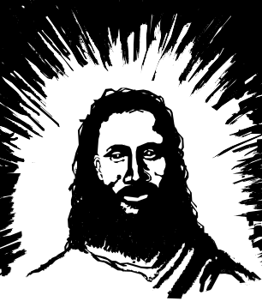
Lord, may this season of Lent
- be a time for conversion and action.
Draw our hearts away from selfishness
-turn our lives to loving sacrifice.
Move our minds away from greed
-turn our thoughts to generosity.
Give us the grace to be true Vincentians who
-love God with the strength of our arms and the sweat of our brows.
Amen
THIRD SUNDAY OF LENT

March 8, 2026
Gospel: (John 4:5-42)
Jesus came to a town of Samaria …Jacob’s well was there. Jesus, tired from his journey, sat down there at the well. It was about noon. A woman of Samaria came to draw water. Jesus said to her, “Give me a drink.” …The Samaritan woman said to him, “How can you, a Jew, ask me, a Samaritan woman, for a drink?” Jesus answered and said to her, “If you knew the gift of God and who is saying to you, ‘Give me a drink,’ you would have asked him and he would have given you living water.” The woman said to him, “Sir, you do not even have a bucket and the cistern is deep; where then can you get this living water? …Jesus answered and said to her, “Everyone who drinks this water will be thirsty again; but whoever drinks the water I shall give will never thirst; the water I shall give will become in him a spring of water welling up to eternal life.”…Meanwhile, the disciples urged him, “Rabbi, eat.” But he said to them, “I have food to eat of which you do not know.”…”My food is to do the will of the one who sent me and to finish his work.”
Reflection:
Thirst is a metaphor for conversion. It captures the dynamic of encountering Christ, hearing his voice, seeing our lives for what they are, and then turning to Christ who is the source of our thirst. Christ is the “gift of God” who gives us the “living water” of his own preaching, dying, and rising. All we need do is drink deeply and we, too, will never thirst again. It is then that we will be able to say with Jesus, “My food is to do the will of the one who sent me and to finish his work.” (Living Liturgy,p.72)
Vincentian Meditation:
“A sure way for a Christian to grow rapidly in holiness is a conscientious effort to carry out God’s will in all circumstances….Each one should show a great eagerness in that sort of openness to God’s will which Christ and the saints developed so carefully.”
-St. Vincent de Paul-
Discussion: (Share your thoughts after a moment of silence)
Vincent always discerned every action carefully to be sure that it was rooted in God’s will. He studied the Gospels, asked for advice and prayed for God’s light and strength. Think back to an occasion when the sense of doing God’s will was especially strong for you, and share this experience.
Closing Prayer:
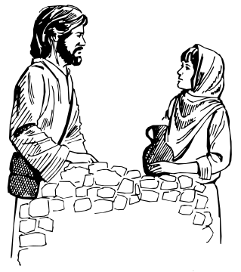
The Church constantly calls us to spiritual renewal, and so we pray:
As we abandon ourselves to God’s will
renew in us your Spirit, O God.
As we allow prayer to change our lives
be present to us, O God.
As we seek to know Christ ever more fully
transform us, O God.
As we serve Christ faithfully in the person of the poor
strengthen us, O God.
Amen

FOURTH SUNDAY OF LENT
March 15, 2026
Gospel: (John 9:1-41)
As Jesus passed by he saw a man blind from birth. His disciples asked him, “Rabbi, who sinned, this man or his parents, that he was born blind?” Jesus answered, “Neither he nor his parents sinned; it is so that the works of God might be made visible through him. We have to do the works of the one who sent me while it is day. Night is coming when no one can work. While I am in the world, I am the light of the world.” When he had said this, he spat on the ground and made a clay with the saliva, and smeared the clay on his eyes, and said to him, “Go wash in the Pool of Siloam”—which means Sent—. So he went and washed, and came back able to see.
Reflection:
It is the man born blind—but who can now see—that is “sent” to bear the good news. As beggar and sinner the man is not worth of the miracle. But Jesus came precisely to save sinners! In our baptism and confirmation we are anointed. Like the man born blind in the gospel, we are transformed from not seeing (sinner) to seeing, from darkness to children of light. We are light. And also like the man born blind, we are sent to help others see and come to believe. (Living Liturgy, p.76)
Vincentian Meditation:
Before a Vincentian can be a sign of God’s love, a sign of God’s generosity, a sign of God’s service, he or she must have personal experience of God’s love, God’s generosity, God’s service. The most unfortunate people in society are those who have not had the experience of being loved. Before loving other, we must come to the realization that we are at every moment of our lives being loved by God. If we do not reflect often in prayer on the fact that the love of God is flowing down upon us at each moment of the day, it will be difficult for us to show love to others, to show love to the poor. May you have a love for the poor and be generous to the poor and be of service to the poor but, more importantly, may you have each day a fresh experience of God’s love, of God’s generosity and of God’s service. (McCullen, Deep Down Things, p.670)
Discussion: (Share your thoughts after a moment of silence)
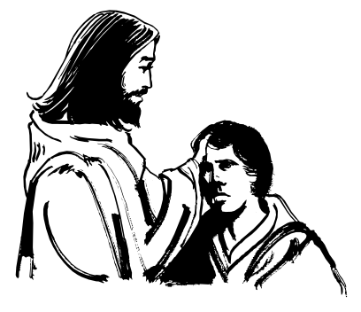
How have you experienced God’s love, God’s generosity and God’s service?
Closing Prayer:
O God, you are the healer of souls and so we pray:
When we are blind,
-may we find your light.
When we come to you in prayer,
-may we experience your love.
When we serve the poor,
- may we know your generosity.
Amen

FIFTH SUNDAY OF LENT

March 22, 2026
Gospel: (John 11:1-45)
So Jesus came to the tomb. It was a cave, and a stone lay across it. Jesus said, “Take away the stone.” Martha, the dead man’s sister, said to him, “Lord, by now there will be a stench; he has been dead for four days.” Jesus said to her, “Did I not tell you that if you believe you will see the glory of God?” So they took away the stone. And Jesus raised his eyes and said, “Father, I thank you for hearing me. I know that you always hear me; but because of the crowd here I have said this, that they may believe that you sent me.” And when he has said this, he cried out in a loud voice, “Lazarus, come out!” The dead man came out, tied hand and foot with burial bands, and his face wrapped in a cloth. So Jesus said to them, Untie him and let him go.” Now many of the Jews who had come to Mary and seen what he had done began to believe in him.
Reflection:
Jesus promises Martha (and us) that whoever “lives and believes in me will never die.” The amazing fact of our living the dying and rising of the paschal mystery is that we already share in this eternal life. We readily see the dying in our everyday lives-the pain, suffering, death, sinfulness, self-emptying, discipline, giving up our wills. This gospel challenges us to see and believe equally signs of the grace of new life-glory, joy, peace, forgiveness, mercy, trust, kindness. Living the paschal mystery draws us to see these dyings and risings as two aspects of the same mystery. The already of eternal life is God’s grace already working in our lives. (Living Liturgy, p. 80)
Vincentian Meditation:
“Five years ago Thou didst bring me back almost from death, and was not this delay granted me to do penance and become better? Ah! The prayers that were sent up to Thee then were heard. Why should those that are being offered now, and in so far greater number, on my behalf, be lost? Perhaps Thou wilt answer them, Lord, in another way. Thou wilt give me courage, resignation, peace of soul, and those ineffable consolations that accompany Thy real presence.”-Bl. Frederic Ozanam- (Ramson, Praying with Frederic, pp. 108-109)
Discussion: (Share your thoughts after a moment of silence)
How has God answered your prayers?
Closing Prayer:

O God, you are the healer of souls and so we pray:
When we are lonely
-may we feel your presence.
When we are burdened by worries
-may we be at peace in your love.
When we have sinned
-may we know your forgiveness.
Amen

PALM SUNDAY OF THE LORD’S PASSION
March 29, 2026
Gospel: (Matthew 21: 1-11 and 26: 14-27)
When Jesus and the disciples drew near Jerusalem and came to Bethphage on the Mount of Olives, Jesus sent two disciples, saying to them, “Go into the village opposite you, and immediately you will find an ass tethered, and a colt with her Untie them and bring them here to me. And if anyone should say anything to you, reply,’ The Master has need of them.’” …The crowds preceding him kept crying out and saying: “Hosanna to the Son of David; blessed is he who comes in the name of the Lord; hosanna in the highest.” After they had crucified him, they divided his garments by casting lots. The centurion and the men with him who were keeping watch over Jesus feared greatly when they saw the earthquake and all that was happening, and they said, “Truly, this was the Son of God!”
Reflection:
From the high hosanna acclamation to the low of betrayal, denial, and abandonment the gospel take us up and down to the brink of life itself. Like the disciples, we also know who Jesus is. Every Sunday we make our profession of faith: “We believe in one Lord, Jesus Christ, the only Son of God…” This Palm Sunday we are invited to reflect on our own knowledge of who Jesus is and how well we confess him in our daily living. It is a daily choice to live the gospel’s requirement that we die to ourselves for the sake of others. This is how we confess Jesus as the Son of God. This is how, rather than denial and abandonment, we come to stand at the cross with Jesus. (Living Liturgy, p 88)
Vincentian Meditation:
“The earth has grown cold. It is for us Catholics to revive the vital beat to restore it, it is for us to begin over again the great work of regeneration, if necessary to bring back the era of the martyrs. For to be a martyr is possible for every Christian, to be a martyr is to give his life for God and his brothers, to give his life in sacrifice, whether the sacrifice be consumed in an instant like a holocaust, or be accomplished slowly and smoke night and day like perfume on the altar. To be a martyr is to give back to heaven all that one has received: his money, his blood, his whole soul..” – Bl. Frederic Ozanam (Letter 90, to Curnier, 1835)
Discussion: (Share your thoughts after a moment of silence)
Indeed, the “Master has need of us” to rekindle the vital fire which has been extinguished in our world. What form has martyrdom taken for you or for those who are dear to you?

Closing Prayer:
Lord, give us the generosity of martyrs, so that we can give:
to an enemy, forgiveness
to an opponent, tolerance
to our family, love and respect
to all men and women, charity.
Amen

REFERENCES:

Gibson, Audrey DC and Kieran Kneaves DC, Praying with Louise de Marillac, Saint Mary’s Press, Winona, Minnesota,1995.

*Maloney, Robert CM. Seasons in Spirituality: Reflections on Vincentian Spirituality in Today’s World, New City Press, Hyde Park, New York, 1998.

*Father Robert Maloney was born and raised in Brooklyn, New York. He was the Superior General of the Congregation of the Mission and the Daughters of Charity, and of the Vincentian Family from 1992-2004.

**McCullen, Richard CM. Deep Down Things, New City Press, Hyde Park, New York 1995.
** Father Richard McCullen from Ireland, was the Superior General of the Congregation of the Mission and the Daughters of Charity, and of the Vincentian Family from 1980-1992.

McKenna, Thomas CM. Praying with Vincent de Paul, Saint Mary’s Press, Winona, Minnesota, 1994.

Ramson, Ronald CM. Praying with Frederic Ozanam, Saint Mary’s Press, Winona, Minnesota, 1998.

Zimmerman, Joyce Ann C.PP.S. et al. Living Liturgy, The Liturgical Press, Collegeville, Minnesota, 2002.

Clip Art: Liguori Publications, Faithware – Cycle A, Liguori, Missouri, 1998.

For information contact:
Timothy P. Williams
Society of St. Vincent de Paul

Council of the United States
66 Progress Parkway
St. Louis, MO 63043-3706
Phone: 314-576-3993
E-MAIL: twilliams@svdpusa.org

Copyright: December 2026-The Society of St. Vincent de Paul Council of the United States.



The Vincentian Weekly Reflections have been developed exclusively for use by the Society of St. Vincent de Paul and the Vincentian Family. They cannot be reproduced in any form without the expressed consent of the National Council of the Society of St. Vincent de Paul.

